STM32F103 Vision Pick-and-Place Host Software User Manual
Project: E:\STM32F103_VisionPickPlace\HostStm32F103ZET
Software: VisionPickPlaceSTM32F103, interface version shown as V2.92
Scope: This English manual covers the host software workflow excluding the vision section. It includes startup, MCU connection, task editing, task running, operation panel, system parameters, IO/motor monitoring, and troubleshooting. The Vision Coordinate, Intrinsic Calibration, camera, ROI, and vision calibration workflows are not included in this version.

1. Before Use
1. Make sure the STM32 firmware has been downloaded to the controller board, and check power, emergency stop, limit switches, air/vacuum circuits, and mechanical clearance.
2. Connect the host PC to the controller communication port.
3. Start the host software:
E:\STM32F103_VisionPickPlace\HostStm32F103ZET\bin\Debug\net10.0-windows\VisionPickPlaceSTM32F103.exe
4. After startup, the host will try to connect to the MCU automatically. When connected, the status bar shows machine connection and heartbeat information.
Safety notes:
- Before running tasks, changing motion parameters, switching modes, or executing multi-axis reset, confirm that the motion area is clear.
- Immediate Stop stops all tasks and motors immediately; Buffered Stop stops after the current instruction finishes.
- System Reset stops all tasks and motors, restarts the MCU, and waits for automatic reconnection.
- Multi-Axis Reset is only available in interpolation mode. Confirm homing direction, limit switches, and travel parameters before using it.

2. Main Window Overview
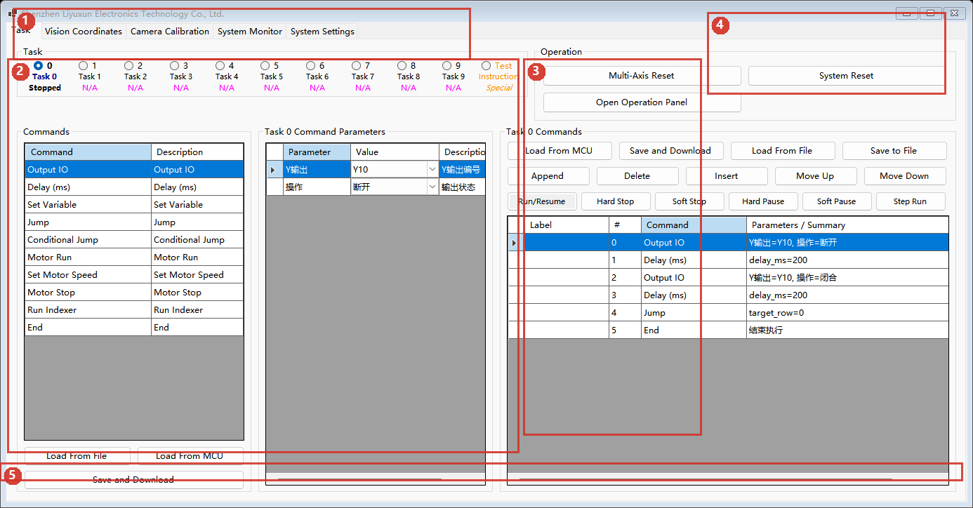
Figure 1. Task Page
Figure 1:
1. Top tabs: this manual mainly uses Task, System Monitor, and System Parameters. Vision-related tabs are not covered here.
2. Instruction editing area: select an instruction type on the left and edit its parameters in the middle.
3. Current task instruction table: shows the task sequence. Instructions can be inserted, deleted, moved up/down, and run step by step.
4. Operation area: global controls such as Multi-Axis Reset, System Reset, and Open Operation Panel.
5. Status bar: shows operation result, machine connection, heartbeat, and runtime status.
Task slots:
- Slots 0 to 9 are system task slots.
- Test is used for temporary instruction testing and debugging.
- Common task states include Empty, Stopped, Running, Paused, Done, and Error.
- Double-click a task name to edit its display name.

3. Startup and Connection
1. Open the host software and check the status bar at the bottom.
2. If the machine is connected and heartbeat updates normally, MCU communication is working.
3. If the machine is not connected, open System Parameters and check the communication port settings. Typical default settings are:
- Protocol port: TTL
- Trace/debug port: CH340 serial
4. After changing communication settings, use Save and Download, then reconnect or restart as prompted.
After connection, the host reads system parameters and task information from the MCU. If local default configuration exists at Data\ProjectDefault\config_default.json, the host also uses it for task names, point names, display names, and local metadata.

4. Operation Panel
Click Open Operation Panel on the Task page to open the large-button operation window.
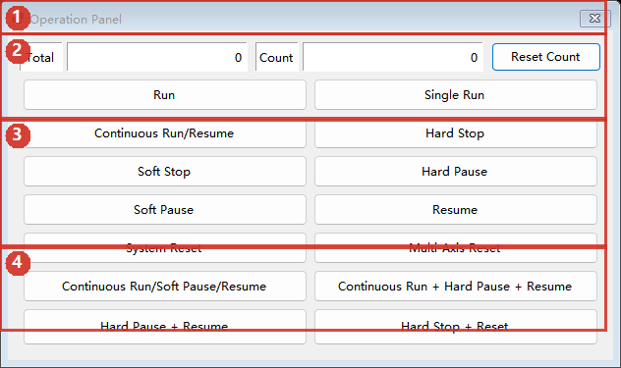
Figure 2. Operation Panel
Figure 2:
1. Counter area: Total is the accumulated total count. Count is the current count segment. Reset Count clears the current segment only.
2. Start area: Run, Single Run, and Continuous Run/Resume.
3. Stop/pause area: immediate stop, buffered stop, immediate pause, buffered pause, and resume.
4. Reset and combined buttons: system reset, multi-axis reset, and run/pause/resume combined operations.
Button functions:
- Run: starts all runnable tasks in continuous mode.
- Single Run: starts all runnable tasks in single-run mode.
- Continuous Run/Resume: starts when stopped, resumes when paused.
- Immediate Stop: immediately stops all tasks and motors.
- Buffered Stop: stops after the current instruction finishes and releases resources.
- Immediate Pause: pauses all tasks immediately and releases resources.
- Buffered Pause: pauses after the current instruction finishes while keeping resources.
- Resume: resumes paused tasks.
- System Reset: stops all tasks and motors, restarts MCU, and waits for host reconnection.
- Multi-Axis Reset: runs the multi-axis homing/reset workflow in interpolation mode.
- Continuous Run/Buffered Pause/Resume: run when stopped, buffered pause when running, resume when paused.
- Continuous Run + Immediate Pause + Resume: run when stopped, immediate pause when running, resume when paused.
- Immediate Pause + Resume: press to pause immediately, release to resume.
- Immediate Stop + System Reset: press to stop immediately, release to reset the system.

5. Task Editing Workflow
Typical workflow:
1. Select task slot 0-9 or Test.
2. Select an instruction from the instruction list, such as Output IO, Delay (ms), Motor Run, Move to Point, Pick/Place, or End.
3. Click Add or Insert to add it to the task instruction table.
4. Select an instruction row and edit its parameters.
5. Use Move Up, Move Down, and Delete to adjust the sequence.
6. Make sure the task ends with an End instruction.
7. Click Save and Download for the current task to save it into local default configuration and download it to MCU.
Common instruction types:
- Output IO: controls Y output state.
- Delay (ms): waits for the specified time.
- Set Variable: modifies internal variables used for counters, flags, and conditional logic.
- Jump / Conditional Jump: changes the next executed task row.
- Motor Run, Set Motor Speed, Motor Stop: controls non-interpolation or auxiliary motors.
- Run Indexer: controls indexer/rotary table actions.
- Move to Point, Move to XYZR, Relative Move: interpolation-mode motion instructions.
- Pick/Place, Pick, Place: pick-and-place actions in interpolation mode.
- Home, Single-Stage Home: axis homing actions.
- End: ends the current task.
Task read/write buttons:
- Load From MCU: reads the current task slot from MCU.
- Save and Download: saves the current task to local config_default.json and downloads it to MCU.
- Load From File: loads task data from local default configuration.
- Save to File / Save Local: saves the current task or all tasks for backup and recovery.
Notes:
- If a task is not ready in the MCU, the software may try to download it and start again.
- The Test task and system tasks 0-9 are mutually exclusive while running or paused.
- After editing a task, save and download it before running.

6. Task Points and Point Matrix
The task point table stores X/Y/Z/R coordinates. These points are used by motion and pick-place instructions.
Common operations:
- Add: add a point at the end.
- Insert: insert a point above the selected row.
- Delete: delete selected points.
- Select All: select or clear all points.
- Load From MCU: read the point table from MCU.
- Save and Download: save points to local default configuration and download them to MCU.
- Load From File: load points from local default configuration.
- Set Current Point: write the current machine position into the selected point.
- Move to Selected Point: move the machine to the selected point.
- Generate Matrix: generate evenly distributed points from start/end coordinates and count.
- Apply + / Apply -: apply positive or negative offset to selected points.
Recommendations:
- Use low speed and short movement for first-time point verification.
- Before moving to a selected point, confirm that the coordinate is within the configured travel range.
- Back up point data before applying batch offsets.

7. Single Task Running and Debugging
The current task area provides local controls for the selected task slot:
- Run/Resume: runs the selected task or resumes it if paused.
- Immediate Pause: pauses the current task immediately and releases resources.
- Buffered Pause: pauses after the current instruction finishes.
- Immediate Stop: stops the current task immediately.
- Buffered Stop: stops after the current instruction finishes.
- Step Run: executes the selected instruction row, useful for debugging.
Debugging suggestions:
- Verify new tasks in the Test slot or a low-risk condition first.
- Select the target instruction row before using step run.
- For IO, vacuum, motor, and axis movement instructions, confirm the mechanism state first.

8. System Parameters: Common Settings
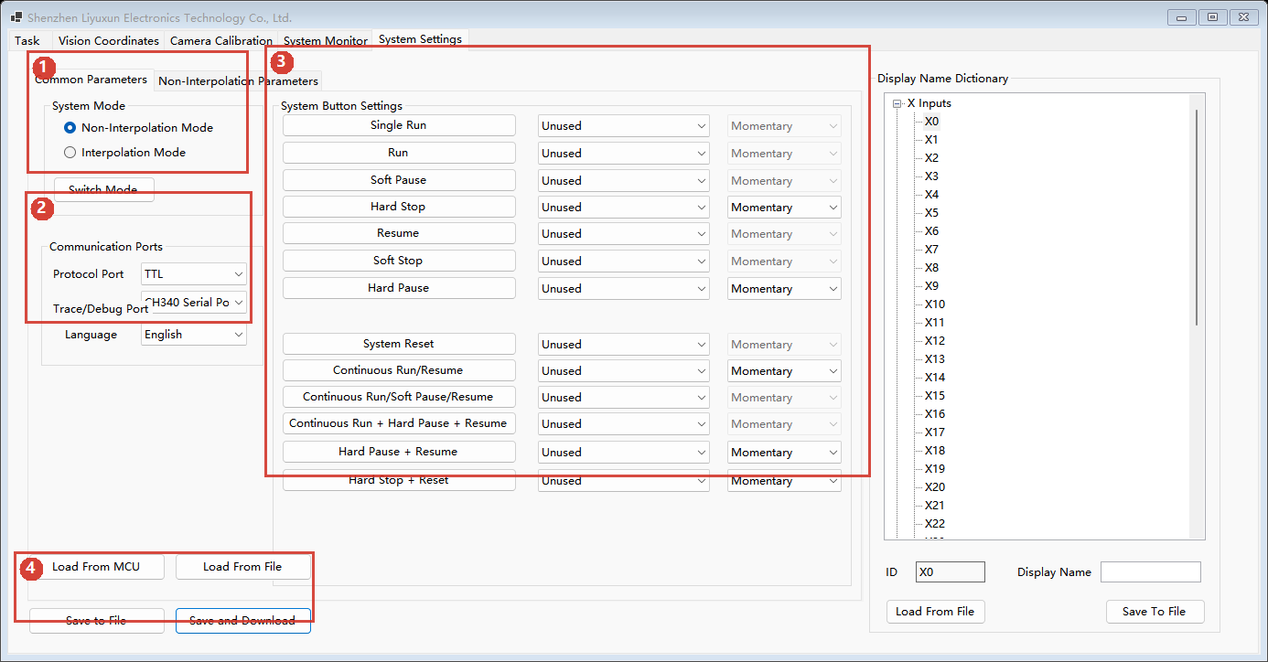
Figure 3. System Parameters - Common Settings
Figure 3:
1. System mode: switch between Non-Interpolation Mode and Interpolation Mode.
2. Communication ports: configure protocol port, debug/trace port, and UI language.
3. System button settings: map physical X inputs to run/stop/pause/reset functions and choose momentary or hold button type.
4. Parameter read/write buttons: load from MCU, load from file, save to file, and save/download.
System mode:
- Non-Interpolation Mode: mainly uses individual motor default speed and auxiliary motor actions.
- Interpolation Mode: enables XYZR interpolation, task points, pick-place workflow, and multi-axis reset.
- Switch Mode requires system restart. After confirmation, the software saves config_default.json, writes mode parameters to MCU, performs system reset, and waits for reconnection.
Physical button settings:
- The left column shows the function name, the middle column selects the physical X input, and the right column selects the button type.
- Unused means no physical input is assigned.
- Safety-related functions such as immediate stop and reset should use reliable, clearly labeled physical buttons.

9. System Parameters: Interpolation Settings
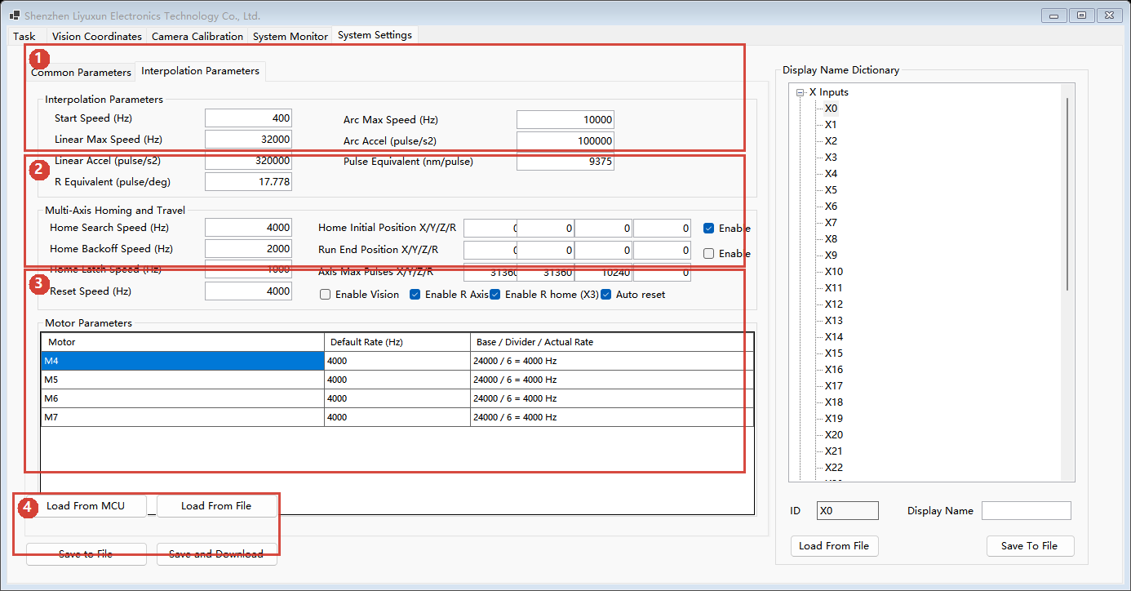
Figure 4. System Parameters - Interpolation Settings
Figure 4:
1. Interpolation speed/acceleration parameters: start speed, linear/circular max speed, acceleration, pulse equivalent, and R-axis angle equivalent.
2. Multi-axis homing and travel parameters: Home search/backoff/latch speed, reset speed, home initial position, run-end position, and max travel.
3. Auxiliary motor parameters in interpolation mode, usually M4-M7.
4. Parameter read/write buttons.
Parameter notes:
- Start Speed (Hz): initial frequency for interpolation motion.
- Linear Max Speed (Hz): maximum speed for linear interpolation.
- Linear Accel (pulse/s2): acceleration for linear interpolation.
- Circular Interp Max Speed and Circular Interp Accel: speed and acceleration for arc interpolation.
- Pulse Equivalent: linear distance per pulse, used for coordinate conversion.
- R Axis Pulse Angle Equivalent: R-axis pulse-to-angle conversion.
- Home Initial Position X/Y/Z/R: target position after homing.
- Axis Max X/Y/Z/R: maximum allowed travel for each axis.
- Auto Multi-Axis Reset After System Reset: automatically runs multi-axis reset after system reset.
Recommendations:
- Record original values before changing travel, pulse equivalent, or R-axis equivalent.
- Save to file before downloading changed parameters to MCU.
- After parameter changes, verify with low-speed dry run or step debugging.

10. System Parameters: Non-Interpolation Settings
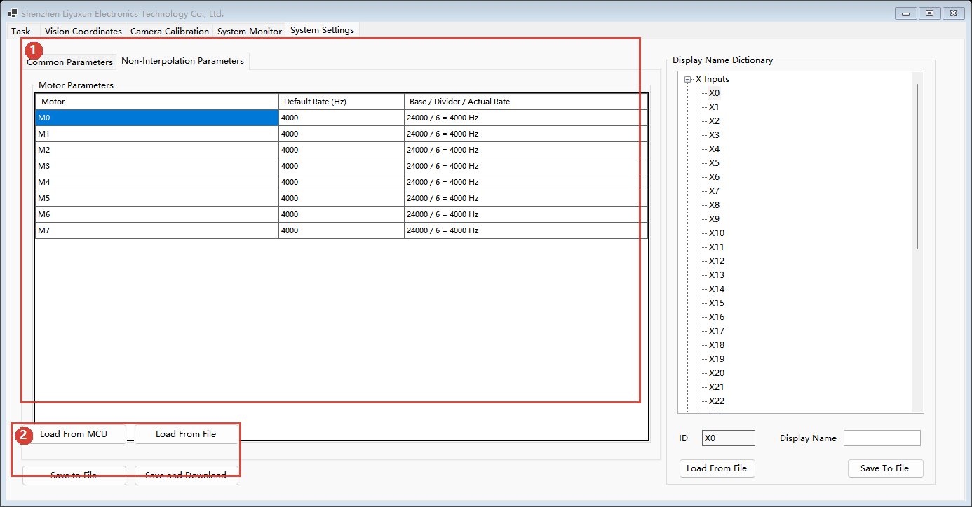
Figure 5. System Parameters - Non-Interpolation Settings
Figure 5:
1. Motor parameter table: shows default speed, base frequency, divider, and actual speed for M0-M7.
2. Parameter read/write buttons.
Usage:
- Change Default Speed (Hz) for each motor as needed; the actual output frequency is calculated from the base frequency and divider.
- Before testing a motor individually, confirm that it is allowed in the current mode.
- In interpolation mode, M0-M3 are normally controlled by interpolation and should not be manually tested as independent motors.

11. System Monitor
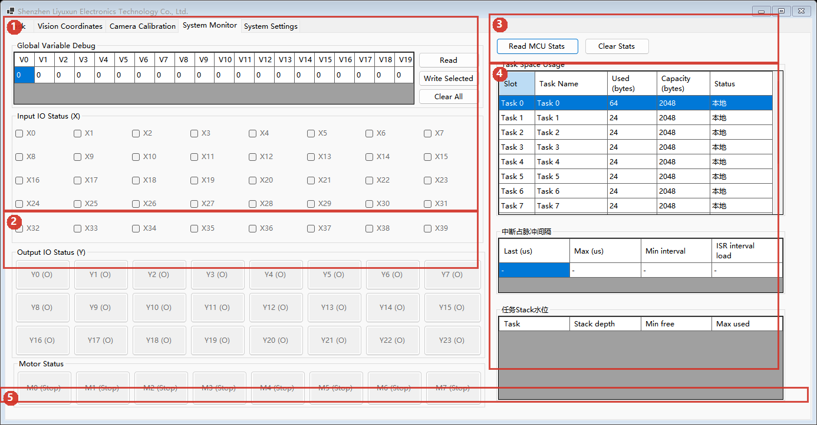
Figure 6. System Monitor
Figure 6:
1. Global variables and X input status.
2. Y output status and motor status.
3. Statistics buttons: read MCU statistics and clear statistics.
4. Runtime statistics: task memory usage, interrupt load, and task stack watermarks.
5. Status bar.
Global variables:
- Read: reads V0-V19 from MCU.
- Write Selected: writes the selected variable to MCU.
- Clear All: clears all 20 global variables.
IO and motor status:
- X inputs are status displays from heartbeat data.
- Y output buttons can send IO toggle commands when allowed; in interpolation mode, some Y outputs are used for direction control and are display-only.
- Motor buttons can start or stop default-speed motor tests when allowed; in interpolation mode, M0-M3 are normally display-only.
Statistics:
- Read MCU Statistics: refreshes task usage, interrupt timing, stack statistics, and global variables.
- Clear Statistics: clears MCU-side statistics.

12. Common Workflows

12.1 Download and Run a Task
1. Select a task slot.
2. Edit instructions and parameters.
3. If the task uses points, edit and download task points first.
4. Click Save and Download for the current task.
5. Click Run/Resume to run the selected task, or open the operation panel and click Run to run all runnable tasks.
6. Watch the status bar, task state, IO status, and real machine movement.

12.2 Modify System Parameters
1. Open System Parameters.
2. Click Load From MCU first.
3. Modify the required parameters.
4. Click Save to File for backup.
5. Click Save and Download to write parameters to MCU.
6. For motion-related changes, verify with low-speed dry run.

12.3 Switch Between Modes
1. Open System Parameters -> Common Settings.
2. Confirm the machine is connected.
3. Click Switch Mode.
4. Check current mode and target mode in the confirmation dialog.
5. Confirm. The software writes mode parameters to MCU, performs system reset, and waits for reconnection.
6. After reconnection, load parameters from MCU again and confirm the mode.

12.4 Handle Abnormal Stop
1. If there is collision, overtravel, or unsafe motion risk, use emergency stop or Immediate Stop.
2. If the current action can finish safely, use Buffered Stop.
3. After stopping, check mechanism state, point data, IO status, and task parameters.
4. If necessary, perform System Reset and wait for reconnection.
5. Before running again, verify with low-speed step run or single-task run.

13. Configuration Files
Local configuration is stored under the host software runtime Data directory:
- Data\ProjectDefault\config_default.json: default configuration for tasks, points, system parameters, and display names.
- Data\ProjectDefault\project_default.json: legacy default configuration file, still supported for reading.
- Data\display.json: display name configuration.
- Data\ui_settings.json: UI language and UI settings.
- Data\ui_text.json / ui_text_custom.json: UI text resources.
Back up Data\ProjectDefault\config_default.json regularly, especially before changing many tasks, points, or system parameters.

14. Troubleshooting
- Machine not connected: check controller power, serial cable, port settings, and driver.
- No heartbeat: check MCU firmware, protocol port, and whether the serial port is occupied by another program.
- Save/download failed: confirm the machine is connected, task parameters are valid, and MCU is not busy.
- Multi-axis reset unavailable: confirm the system is in interpolation mode.
- Run blocked and reset required: perform System Reset, wait for reconnection, then run again.
- IO or motor button has no effect: confirm this IO/motor is allowed in the current mode and machine is connected.
- Parameter text turns red: the UI value differs from the saved baseline. Save or reload parameters to clear the warning.

